Possible questions - analysis
Friday, 18 September 2026
11:39 pm

作为新加坡一家金融公司的老板、CEO + HR director，他在招聘技术负责人的时候，看重的条件包括：
1、技术资深经验
2、金融行业经验
3、带团队经验
4、行业影响力
5、性格是否与CEO合拍，是否抗压性强，
6、有没有创新精神、
7、对未来的规划是否与公司合拍

Note:tokenisation

问题列表：
1、自我介绍
2、离职原因
2、项目经验，引出银行中的零售业经验的理解、认知深度，
3、下家公司期望的条件:包括选择哪些行业（因为你的离职原因包括拓宽金融行业涉及范围）;
5、AI相关话题：
6、我要准备一个产品给CEO看

IFS capital - JD
Saturday, 19 September 2026
10:37 pm

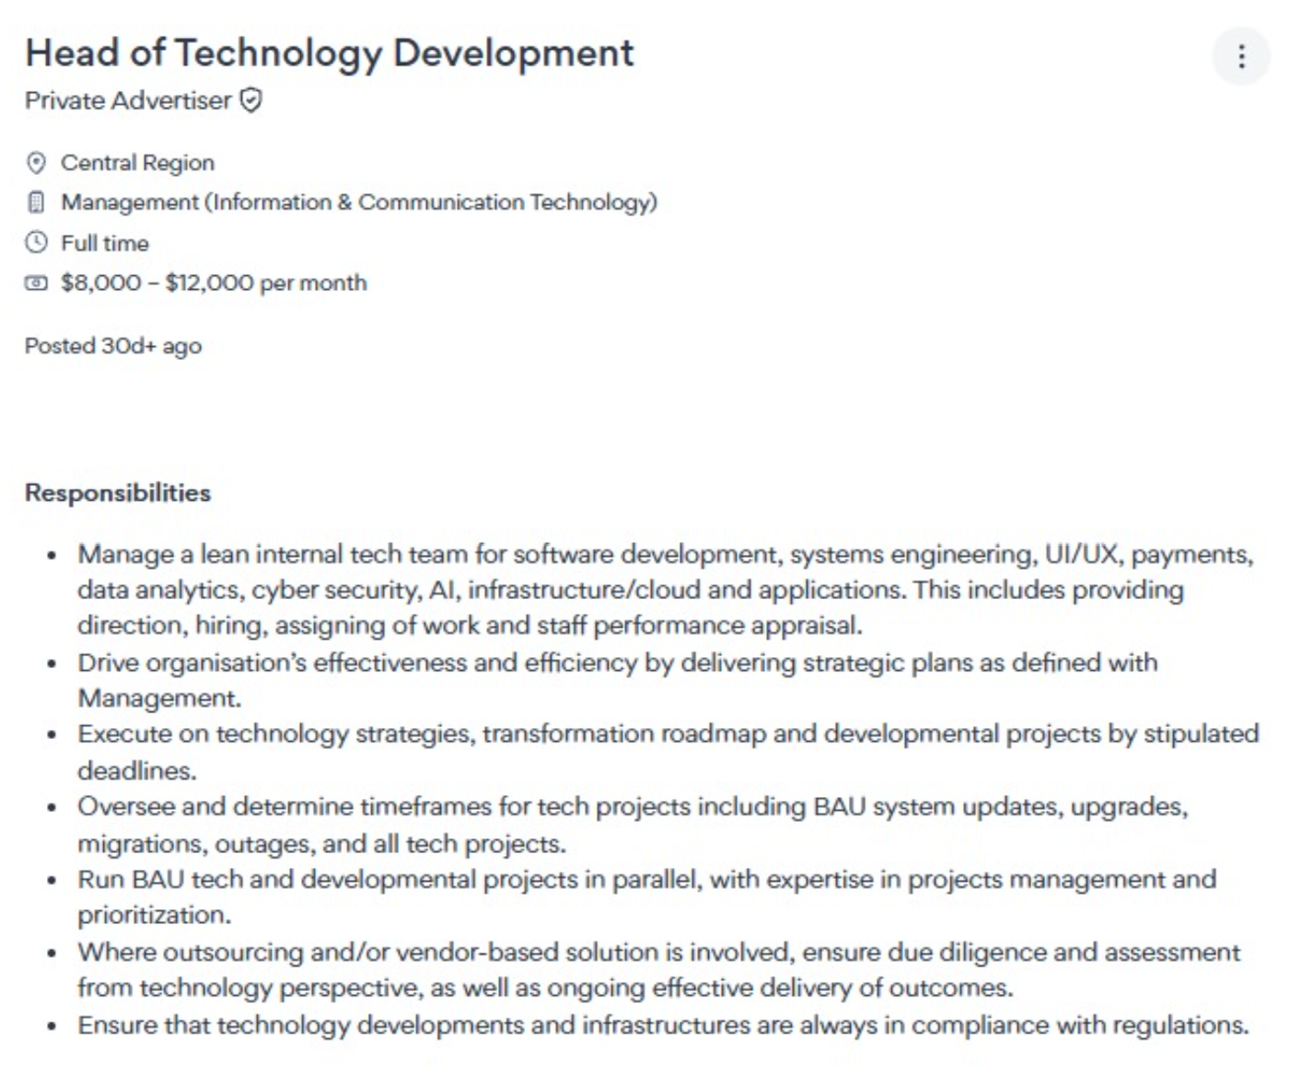

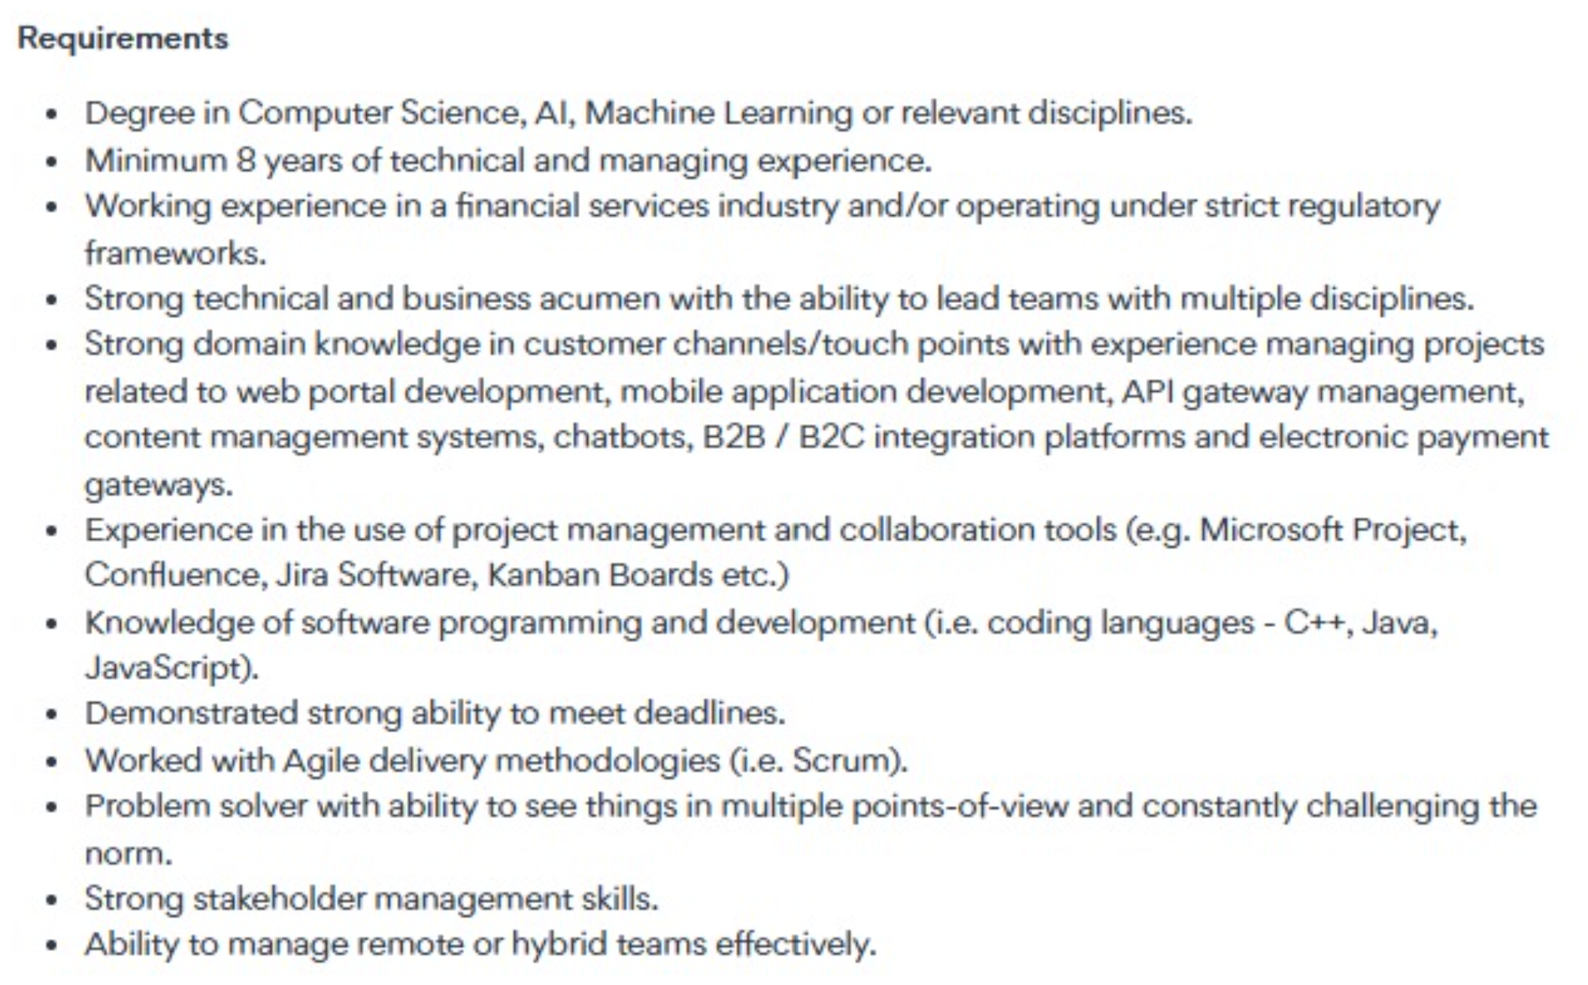

交叉必对齐口径 + 你要反问的问题
Alignment Across Interviewers + Questions to Ask Back
两人都会盯的三个点——CEO 与 HRD 口径必须一致:
Three things both will watch — CEO and HRD answers must align:
- • 承诺与留存:CEO 从「能不能一起长期建」问,HR 从「会不会做一两年就走」问——两边答案要一致。
Commitment & retention: CEO asks "can you build long-term with us," HR asks "will you leave in a year or two" — keep both answers consistent.
- • 负责任的 AI / 客户信任:全集团(尤其 Randy)反复讲的价值观,你要有清晰立场。
Responsible AI / customer trust: a value the whole group (especially Randy) repeats — have a clear stance.
- • 小团队高杠杆:CEO 关心 scale,HR 关心团队健康——答案要同时满足「产能放大」与「人不被榨干」。
Small team, high leverage: CEO cares about scale, HR about team health — satisfy both "multiply output" and "don't burn people out."

IFS - possible questions
Sunday, 20 September 2026
11:10 am
1、can you introduce yourself？
Ans:
C360 is a regional Group customer relationship management project, providing

2、why leave，why you are choosing for new opportunity？Why do you want to leave UOB?
Ans:
So for me, it’s mainly about career growth and broadening

3、what technologies are you using in UOB?
Ans:

- Website: Spring boot, spring Batch、camel、Linux、shell、FTP、kafka、gateway
- Compliance:

层面 | 主要检查什么 | 例子
1. 客户合规 | 客户是谁、是否有风险 | KYC、AML、Sanctions Screening、PEP
2. 交易合规 | 这笔交易是否存在风险 | 制裁名单、可疑交易、金额/国家/收款人风险、Transaction Monitoring
3. 数据合规 | 数据是否被正确使用和保护 | PDPA、数据隐私、数据质量、数据留存、数据访问权限
4. 流程/运营合规 | 银行做事的流程是否符合监管和内部政策 | Maker-Checker、审批、授权、审计记录、监管报告、异常处理
  - 例如一笔跨境支付：
Customer
↓
KYC / Customer Risk
↓
Payment
↓
Sanctions Screening ──→ External API / Screening Provider
↓
AML / Transaction Monitoring
↓
Risk Scoring / Big Data Analysis
↓
Approval / Investigation
↓
Payment Processing
↓
Audit Trail / Regulatory Reporting

- 一句话总结: 银行合规 = 客户合规 + 交易合规 + 数据合规 + 流程/运营合规 + 监管报告与审计

- DB： Oracle、MySQL cloud、redis、MongoDB;
- Risk management： API gateway、Axway, Oauth, JWT,
- AI/ Big data:
  - Spark, Hadoop, Map Reduce, ETL,
  - RAP, vector database, LLM, AI agent workflow,

4、what's new tech can you bring to this industry/company?
Ans:
- Bank prod delivery rigor, and regulatory compliance
- Still Hands on
- Breadth of expertise: 18 years spanning CTO, Architect, and PM roles
- Pragmatic and cost-conscious:
- Payment gateway, B2C, B2C
- AI & Big data analysis

5、what's your strangth and weakness?
- Strength：
  - Management: Built a team of 100+ people vs manage Vendors from parts of the world
  - startup vs Established Enterprise
  - PM: Agile vs waterfall project

- Weakness
  - My experience covers Retail banking, cross-border payment, quantitative Trading, Compliance. But no lending product;

6, Do you think you're good fit for this company?
Ans:
Yes.
- I have B2B, B2C experience, payment, retail banking, RM, etc.
- And start up company, built a 100 people team from scratch, multi-team mmgt
- large Project management,
- Big data analysis, AI agent project built
- Problem solving

7,

CEO Randy Sim — 7 大高危问题 + STAR
Sunday, 20 September 2026
4:40 pm

CEO Randy Sim — 7 High-Stakes Questions + STAR
量化处用 [填:xx] 占位,面试前用你的真实数据替换。主线案例:UOB AI Code Review Service 与 payments(CBPR+/RTGS/ISO 20022 MT→MX 迁移)。
Metrics in [Fill: xx] are placeholders — replace with your real numbers. Anchor examples: UOB AI Code Review Service and payments (CBPR+/RTGS/ISO 20022 MT→MX migration).
Q1 | 你解决的是真问题还是在堆技术?(依据:solve real-world friction / stay close to real problems)
Q1 | Are you solving a real problem, or just piling on tech? (basis: "solve real-world friction / stay close to real problems")
- S: 在银行,代码上线前都要人工审,又慢又容易漏,是交付的一个大卡点。
In a bank, every code change has to be manually reviewed before go-live — slow, easy to miss things, and a real delivery bottleneck.
- T: 我想解决的不是「上一个工具」,而是「人审跟不上、拖慢合规交付」这个真问题。
What I wanted to fix wasn't "add another tool" — it was the real problem: manual review can't keep up and it slows compliant delivery.
- A: 我带团队做了个 AI 帮着审代码的服务(Spring Boot + GitHub 上的 agent)。代码一提交就自动审一遍,有问题当场标出来,合不合并还是人来定。
My team built an AI-assisted code-review service (Spring Boot + an agent on GitHub). The moment code is committed it's auto-reviewed, issues are flagged on the spot, and a person still decides whether to merge.
- R: 上线后审查质量提升了大概 80%,新人上手快了三到四成,工程师不用再盯低级错误、能去做真正要紧的事。一句话:先想清楚业务卡在哪,再用技术去解,不是为用技术而用技术。
After launch, review quality went up ~80% and new joiners ramped 30–40% faster; engineers stopped chasing trivial errors and got back to what matters. In short: work out where the business is stuck first, then solve it with tech — not tech for its own sake.
- 【可选插入·银行细节:若 CBPR+ 里用它拦下过具体的合规/安全问题,补一句真实案例,说服力更强】
[Optional insert · banking detail: if it caught a specific compliance/security issue in CBPR+, add one real example — more convincing.]
Q2 | 你能不能从 0 到 1 建东西、并在不确定中下注?(依据:We're going to keep building;IFSAM 在 PMF 未明时仍 launch)
Q2 | Can you build 0→1 and bet under uncertainty? (basis: "We're going to keep building"; IFSAM launched before PMF was proven)
- S: 在 VV Technology,我从零搭起了 VV-Life——一个连接线下商户的本地生活平台(吃饭、买菜、出行都有)。典型的创业环境:没现成方案、需求天天变、得赶紧验证方向对不对。
At VV Technology I built VV-Life from scratch — a local-lifestyle platform connecting offline merchants (food, groceries, travel, everyday services). A classic startup: no ready template, requirements changing daily, and we had to validate the direction fast.
- T: 方向还没被市场证明的时候,得判断先做什么、怎么小步试、怎么别把风险搞大。
When the direction isn't market-proven yet, you have to decide what to build first, how to test in small steps, and how to keep the risk contained.
- A: 我的做法是先做 MVP:先把最小的消费闭环(网页 + 手机 API + 后端,跑在 AWS 上)做出来,让真实用户先用起来;方向对了再一层层加(实时数据、支付、更多品类)。同时用 CI/CD 自动化 + 监控告警(Splunk),保证跑得快也不出乱子。
My approach was MVP-first: get the smallest working consumer loop out (web + mobile APIs + backend on AWS) and put it in front of real users; once the direction held, add layer by layer (real-time data, payments, more categories). CI/CD automation plus monitoring/alerting (Splunk) kept us fast without breaking things.
- R: 这个平台从零做到每天百万级交易、覆盖好几个区域;[填:真实数字,如用户数 / GMV / 多久上线]。说白了,我敢在方向没定时小步下注、用 MVP 换确定性——跟你们没等 PMF 明朗就先 launch IFSAM 是一个道理。
The platform grew from zero to millions of transactions a day across several regions; [Fill: real numbers — users / GMV / time to launch]. In short, I'll bet in small steps before the direction is fixed and use an MVP to buy certainty — the same logic as your launching IFSAM before PMF was clear.
- 【补充·受监管环境下的 0→1:同一套「先 MVP 再增量」的打法,我在 UOB 的 CBPR+ ISO 20022 迁移上也用了,只是那边「合规内建、可追溯」的门槛更硬。可在 R 后补一句作第二个例子,真实数字请替换。】
[Supplement · 0→1 under regulation: I used the same "MVP then increment" approach on UOB's CBPR+ ISO 20022 migration — just with a much higher bar for built-in compliance and traceability. Add one line after R as a second example; replace the real numbers.]
Q3 | 用一支 lean team 覆盖这么宽,怎么跑出 scale?(依据:精简上市集团、口头禅 at scale)
Q3 | How do you scale with a lean team covering so much? (basis: lean listed group; his phrase "at scale")
- S: 小团队却要什么都管——开发、支付、AI、安全、数据都得覆盖。
A small team, but it has to cover everything — dev, payments, AI, security, data.
- T: 不能靠加人来堆产能。
Scale output without just adding headcount.
- A: 我一般用三招:一是共用底座——支付、数据这些每个市场都要用的,只建一次、大家共用;二是走 SaaS 思维——能共用就共用,服务都做成可配置的,新市场按需求配一下就能用,不用每次重造;三是能自动化就交给工具——比如那个 AI 审代码服务,等于把一个人的审查力放大到全队;非核心的直接买现成,自己只做最能拉开差距的部分。
I usually use three moves. One, a shared base — things every market needs (payments, data) get built once and shared. Two, a SaaS mindset — share what can be shared and make services configurable, so a new market is just a config change, not a rebuild. Three, automate what you can — the AI code-review service, for example, scales one person's review capacity to the whole team; and buy non-core parts off the shelf, build in-house only what really differentiates.
- R: 我以前带过 100 多人的团队,就是靠这种「用杠杆、不堆人」的思路让小队也能扛大盘子;[填:用 X 人扛住 Y 的量]。说白了,我靠杠杆放大产能,不是靠人头。
I've led teams of 100+ using exactly this "leverage, not headcount" mindset so a small squad can carry a big load; [Fill: sustained [Y] with [X] people]. In short, I scale with leverage, not by hiring more people.
- 【可选插入·before-UOB:VV-Life 用不大的团队扛住每天百万级交易 / AI Park 覆盖 1000+ 停车场——「小团队干大事」的例子,二选一】
[Optional insert · before-UOB: VV-Life sustained millions of daily transactions with a lean team / AI Park covered 1,000+ car parks — a "small team, big outcome" example; pick one.]
Q4 | 数据 + AI 怎么增强「人的连接」而不是取代它?(依据:data tells how, engagement tells why;responsible)
Q4 | How does data + AI enhance human connection rather than replace it? (basis: "data tells how, engagement tells why"; responsible)
- S: AI 在面客和风控上确实能提效,但用不好会伤客户信任。
AI really can speed up customer-facing and risk work, but used wrong it damages customer trust.
- T: 要的是既提效、又守住信任和合规。
Get the efficiency and keep trust and compliance.
- A: 我的原则很简单:AI 负责规模化的活——洞察、初筛、提效;真正关键、涉及人的判断,留给人来做。同时把可解释、模型风险、合规卡点做扎实。这就是我在 AI 审代码里的做法:AI 只给建议,合不合并人拍板。
My rule is simple: let AI do the scalable work — insight, first-pass screening, efficiency — and leave the judgment calls that affect people to people. And keep explainability, model risk and compliance gates solid. That's exactly how I run the AI code review: AI only suggests, a human decides the merge.
- R: [填:提效多少 + 零合规事故]。一句话:AI 和人是搭配,不是替代。
[Fill: efficiency gain + zero compliance incidents]. In short, AI and people work together — one doesn't replace the other.
- 【可选插入·before-UOB 面客例子:VV-Life 的实时数据分析 / AI Park 的个性化推荐——「AI 提效但人做主」的面客例子】
[Optional insert · before-UOB customer example: VV-Life real-time analytics / AI Park personalised recommendations — an "AI boosts efficiency, humans decide" customer example.]
Q5 | 风控 / turnaround / 稳定性怎么保证?(依据:Risk Management、Turnaround、Process Re-engineering)
Q5 | How do you ensure risk control / turnaround / stability? (basis: Risk Management, Turnaround, Process Re-engineering)
- S: 跨境支付的报文迁移(MT 换 MX),系统 7×24 不能停、钱不能算错、合规不能破。
A cross-border payments message migration (MT to MX): the system can't go down, the money can't be miscomputed, and compliance can't break.
- T: 要在不停业务的情况下把迁移做完,一次重大事故都不能出。
Finish the migration without stopping the business — not a single major incident.
- A: 核心就一句:不一把梭。先让新旧两套系统并行跑,同一批交易两边都处理、一笔一笔对账,对不上就立刻报警;确认新系统稳了,再分批把流量切过去,一次切一小块,每切一块都留着能马上切回去的后路;全程盯着监控,问题在影响客户之前就拦下来。
The core rule is: don't go all-in at once. First run old and new in parallel — both handle the same transactions, reconcile them one by one, and any mismatch triggers an immediate alert. Once the new system is proven stable, shift traffic in small batches, one slice at a time, always keeping a path to switch straight back. Watch monitoring throughout so problems are caught before they reach customers.
- R: 我在 UOB 用部署频率、MTTR、故障率这些指标盯着交付健康;[填:迁移零重大事故 / SLA 达标]。说白了,我在这种不容错、强监管的环境里,既能守住稳定又能做改造;真接手你们的系统,我会先诊断再动手,不会一上来就大改。
At UOB I track delivery health with deployment frequency, MTTR and change-failure rate; [Fill: zero major incidents / SLA met]. In short, in a zero-error, heavily regulated setting I can keep things stable and still rebuild; on your systems I'd diagnose first, not start with a big rewrite.
- 【可选插入·before-UOB turnaround:VV-Life 通过架构升级把线上重大事故降下来——「接手→稳定住」的补充例子】
[Optional insert · before-UOB turnaround: at VV-Life, architecture modernisation brought critical incidents down — a "took over a mess → stabilised it" example.]
Q6 | 区域/多实体的技术怎么统一又本地化?(依据:SG/MY/ID/TH/HK 多市场、Lendingpot 出海)
Q6 | How do you unify yet localise tech across regions/entities? (basis: SG/MY/ID/TH/HK markets; Lendingpot going regional)
- S: 多个国家、多个子品牌(Lendingpot / Friday / Friyay),每个市场既想复用同一套东西,又得满足当地监管。
Multiple countries and sub-brands (Lendingpot / Friday / Friyay) — each market wants to reuse the same core, yet has to meet local regulation.
- T: 一套平台管全局,还能按各市场快速改。
One platform to run everything, still quick to adjust per market.
- A: 我的做法是走 SaaS 化:每个市场都一样的东西(账户、支付、风控、数据)做成共用底座、只建一次;各地不一样的(货币、语言、监管、报送)做成可配置的一层,按市场和客户需求配一下就行,不动底座。开一个新国家不是重做系统,而是配一套本地规则接上去。这套我很熟——之前创业项目就用 API gateway + 多租户 SaaS 做过,支付/KYC 覆盖过 200+ 地区;ISO 20022 也是同一个道理:全球一个标准,各地做本地扩展。
My approach is to go SaaS: the parts every market shares (accounts, payments, risk, data) become a common base built once; the parts that differ by place (currency, language, regulation, reporting) become a configurable layer you just set per market, without touching the base. Opening a new country isn't rebuilding the system — it's configuring a local rule-set and plugging it in. I know this well — in earlier startup work I built exactly this with an API gateway + multi-tenant SaaS, covering payments/KYC across 200+ regions; ISO 20022 is the same idea: one global standard, local extensions.
- R: [填:一套平台撑 N 个市场 / 新市场上线从 X 缩到 Y]。说白了,我懂「共用」和「本地合规」怎么平衡,payments 背景直接能上手。
[Fill: one platform serving [N] markets / new-market launch cut from [X] to [Y]]. In short, I know how to balance "shared" and "locally compliant," and my payments background applies directly.
- 【选填·项目名:上面「API gateway + 多租户 + 200+ 地区」出自 Golden Bridge;若你想用 VV / AI Park,请按你实际经历改措辞】
[Optional · project name: the "API gateway + multi-tenant + 200+ regions" above is from Golden Bridge; if you'd rather cite VV / AI Park, reword to match your actual experience.]
Q7 | 为什么离开大行来我们这?能待多久?(依据:founder 都会问动机与承诺)
Q7 | Why leave a big bank for us, and how long will you stay? (basis: founders always probe motivation & commitment)
- S/T: 在 UOB,我管的是一台大机器里的一块。
At UOB, I run one piece of a very big machine.
- A/R: 我想要的是端到端自己说了算、亲手把 AI 用到业务里,加入一个正在长大的 SGX 上市 fintech;这对我不是跳板,是我下一段真正想深耕的方向——[比如 3–5 年,把我负责的 fintech 产品做到百万级增长]。说白了,我图的是舞台和成长,不是头衔或短期待着。
What I want is end-to-end ownership, and to put AI into the business with my own hands, at a growing SGX-listed fintech; for me this isn't a stepping stone but the direction I want to go deep in next — [e.g. over 3–5 years, take the fintech product I own to million-scale growth]. In short, I'm after the stage and the growth, not a title or a short stay.
- 【需你确认·真实承诺:把「3–5 年做到 million 级增长」换成你能兑现、且愿意对 CEO 说出口的具体承诺】
[Needs your confirmation · real commitment: replace "3–5 years to million-scale" with a concrete promise you can deliver and are willing to say to the CEO.]

HRD Mei Yun Ching — 高概率问题 + STAR 填空
Monday, 21 September 2026
3:36 pm

HRD Mei Yun Ching — Likely Questions + STAR to Fill
行为题用 STAR 四行自己填;动机/薪资类用要点填。她的人事价值观:「we're in the fair business, not the nice business」——公平高于讨好。
For behavioural questions, fill the four STAR lines; for motivation/pay, use bullets. Her HR value: "we're in the fair business, not the nice business" — fairness over niceness.
Q1 | 以你的资历,为何看这个 level?你真正的动机是什么?(直接题)
Q1 | With your seniority, why this level? What's your real motivation? (direct)
  - 要点①: (具体到 IFS)___
(specific to IFS) ___
  - 要点②: (端到端 ownership / AI 落地 / fintech 成长期)___
(end-to-end ownership / AI in production / fintech growth stage) ___
  - 避坑、Avoid vague lines like "I want a change of environment."
Q2 | 讲一次你做「公平但难」的人事决定(处理低绩效/不受欢迎但正确的决定)。(她的价值观,必考)
Q2 | Tell me about a fair-but-hard people decision (managing out a low performer / an unpopular but right call). (her value — expect it)
  - S: ___
___
  - T: ___
___
  - A: ___(展现「有温度的硬度」:先辅导给机会 → 仍不达标 → 公平而果断)
___ (show "firmness with warmth": coach and give a chance → still short → fair but decisive)
  - R: ___
___
Q3 | 精简、快节奏、亲力亲为(IC)的文化,你从大行过来能适应吗?
Q3 | Can you adapt from a big bank to a lean, fast, hands-on (IC) culture?
  - S: ___(用你的 fintech SaaS 经历:Golden Bridge / VV Technology)
___ (use your fintech SaaS experience: Golden Bridge / VV Technology)
  - T: ___
___
  - A: ___
___
  - R: ___(落点:我不是只会大行流程的人,愿意 hands-on)
___ (Point: I'm not just a big-bank-process person — I'll be hands-on)
  - 【插入·before-UOB:Golden Bridge / VV-Life 在快节奏创业里 hands-on 带 Agile 小队的经历——正好证明你能适应精简文化】
[Insert · before-UOB: Golden Bridge / VV-Life — hands-on leading Agile squads in a fast startup — proves you fit a lean culture.]
Q4 | 你怎么 hiring / 分派工作 / 做 performance appraisal / 留住核心人?(JD 明写)
Q4 | How do you hire / assign work / run appraisals / retain key people? (in the JD)
  - S: ___
___
  - T: ___
___
  - A: ___(给带人方法论:定目标、给反馈、用成长/自主权/项目意义留人,而非只靠钱)
___ (people method: set goals, give feedback, retain with growth / autonomy / meaningful work, not just pay)
  - R: ___
___
  - 【插入·经历:你在 UOB 带 engineering managers + squad leads、做 1:1/技术带教/职业发展,之前带过 100+ 人团队——用这些填 A/R】
[Insert · experience: at UOB you lead engineering managers + squad leads, run 1:1s / technical mentoring / career development, and have led 100+ engineers — use these for A/R.]
Q5 | 你怎么确保团队追交付的同时,不牺牲客户体验和合规底线?(她主持过 responsible lending panel)
Q5 | How do you keep delivery pace without sacrificing customer experience or compliance? (she moderated a responsible-lending panel)
  - S: ___
___
  - T: ___
___
  - A: ___ 先以客户体验和合规底线为根本,再考虑技术方案落地,同时权衡 MVP 范围与 man-day;落到具体机制:code review、合规门禁、客户影响评估。
___ Anchor on customer experience and the compliance line first, then decide how to deliver, weighing MVP scope and man-days; land it in concrete mechanisms: code review, compliance gates, customer-impact assessment.
  - R: ___
___
Q6 | 薪资期望、notice period、到岗时间。(直接题)
Q6 | Salary expectation, notice period, start date. (direct)
  - 话术: 先问整体 package 结构(base + variable + stocks/options 激励)→ 再给区间,别过早锚定。
Script: ask the full package structure first (base + variable + stocks/options) → then give a range; don't anchor early.
  - 你的: 区间/底线:___ notice:___
range/floor: ___ notice: ___

Q7 | 你的管理风格是什么样的？
Ans:
  - Be flexible with people, yet strict about results.
  - Delegate the execution, but adhere to principles on risk and quality.

I do not adult one-size-fits-all; Based their competency level and their initiative level, I will adjust my mgt style accordingly.
 | High initiative | Low initiative
High Competence | 🟢 empowerment | 🟡 目标+激励型  Goal & Incentive
Low Competence | 🟡 教练型Coaching | 🔴 指导/指令型 Directing/Instructing

1. 高能力 + 高自主意愿 → 授权
你负责：
  - 定目标
  - 定边界
  - 定 deadline
  - 定关键风险
  - 定期 check-in
然后：
“You own it. Keep me posted on the key risks and blockers.”
让他自己决定 How

2. 高能力 + 低自主意愿 → 激励 + Accountability

为什么不主动？
可能是：
  - 没有 ownership
  - 不认可目标
  - 缺乏 motivation
  - 工作量/奖励不匹配
  - 担心承担风险
管理方式：
Clear expectation → Ownership → Follow-up → Accountability
例如：
“I don't need you to wait for my instruction. I expect you to identify the issue and propose the solution.”

3. 低能力 + 高自主意愿 → Coaching

应该
Explain → Guide → Let them try → Review → Feedback
例如：
“You own this task. I'll provide guidance, but I want you to come back with your proposed solution first.”

4. 低能力 + 低自主意愿 → Direct / Structured Management
需要：
  - 明确任务
  - 明确 deadline
  - 明确标准
  - 定期检查
  - 明确责任
  - 必要时 Performance Management
但也不要一开始就贴标签。
先判断：
能力问题？态度问题？还是环境/资源问题？

Q8. 你如何激励人 - how do you motivate people?

I believe people are motivated by more than just compensation.

As a Head of Technology, I focus on five things: clear purpose, ownership, growth, recognition, and accountability.
  - First, I make sure people understand what we are building and the business impact behind it.
  - Then I give capable people ownership .
  - I also create opportunities for people to grow technically and move into leadership roles. At the same time, I recognise good contributions and make expectations and accountability very clear.

My goal is to create an environment where people feel trusted, challenged, recognised, and able to grow.
I believe when people have both ownership and growth opportunities, motivation becomes much more sustainable.

反问问题
Monday, 21 September 2026
3:37 pm

1、 Ask Randy (CEO):
- 未来 12 个月,哪个真实业务摩擦是你最想让技术团队先解决的?
In the next 12 months, which real business friction do you most want the tech team to solve first?
- 你希望这个岗更偏守成(BAU 稳定)还是攻坚(转型/AI)?
Do you want this role more toward keeping BAU stable, or driving transformation/AI?

2、反问 Mei Yun(HRD):
- 这个团队现在的健康度/短板在哪?你希望新 Head 先修文化还是先修交付?
What's the team's current health/gaps? Should the new Head fix culture first or delivery first?
- 岗位的 grade、汇报线和成长路径是怎样的?
What are the grade, reporting line, and growth path?
通用反问(验证岗位真实定位):
General questions (to verify the real scope):
- 这个岗汇报给谁?上面有没有 CTO?
Who does this report to? Is there a CTO above?
- 团队现在多少人、什么组成?未来编制?
Team size and composition now? Future headcount?
- 这个岗覆盖 group IT 还是具体平台(Lendingpot/Friday/Friyay)?
Does it cover group IT or specific platforms (Lendingpot/Friday/Friyay)?
- 我的决策权/预算权多大?vendor 选型、招人有没有话语权?
How much decision/budget authority — including vendor choice and hiring?
- 成功的定义 / 前一年的 KPI 是什么?
What's the definition of success / last year's KPIs?

